MINISTRY OF EDUCATION AND TRAINING

FPT UNIVERSITY
SAP341 Project Document
[Project name (Code)]

<Group Name>
Group Members | <Member name><RollNo><Student code >  <Member name><RollNo>< Student code >  <Member name><RollNo>< Student code >  <Member name><RollNo>< Student code >  <Member name><RollNo>< Student code >
Lecture

- Hanoi, August 2025 -

Table of Contents

Acknowledgement 3
Definition and Acronyms 3
I. Project Introduction 4
1. Overview 4
2. Product Background 4
3. Existing Solutions 4
4. Project Scope & Limitations 4
II. Software Requirement Specification 5
1. Requirement Overview 5
2. Functional Specifications 5
4. Non-Functional Requirements 6
5. Requirement Appendix 6
III. Software Design Description 6
1. System Design 6
2. Database Design 6
IV. Software Testing Documentation 6
1. Scope of Testing 6
2. Test Strategy 7
3. Test Cases 7
4. Test Reports 7

Acknowledgement
[Fill team’s acknowledgement here…]

Definition and Acronyms
[Fill all the definitions, acronyms,… used within the document] in the table format as below]
Acronym | Definition
PWM | Psychology website
AWS | Amazon Web Services
BA | Business Analysis
BR | Business Rule
ERD | Entity Relationship Diagram
GUI | Graphical User Interface
PM | Project Manager
SDD | Software Design Description
SPMP | Software Project Management Plan
SRS | Software Requirement Specification
UAT | User Acceptance Test
UC | Use Case
API | Application Program Interface

I. Project Introduction
[Provide final project introduction information follow the template as part II in the Report #1]

1. Overview

1.1 Project Information
[Provide the brief information of the project: project name, project code, group name, etc.]

1.2 Project Team
[List out the details of the project team and stakeholders…]
STT | Member | Task/Screen
1 | Nguyễn văn A | Login/register/view list product; product background, Test plan

2. Product Background
[This section summarizes the rationale for the new product. Provide a general description of the history or situation that leads to the recognition that this product should be built. You should also mention here the information on the customer /the people who raise project idea/request]

3. Existing Solutions
[Add the system which might help solving the problems you listed above or the systems in which you can learn/refer the features for your system design]

4. Project Scope & Limitations
[The project scope defines the concept and range of the proposed solution. It’s also important to define what will not be included in the product. Clarifying the scope and limitations helps to establish realistic expectations of the many stakeholders. It also provides a reference frame against which proposed features and requirements changes can be evaluated. Proposed requirements that are out of scope for the envisioned product must be rejected, unless they are so beneficial that the scope should be enlarged to accommodate them (with accompanying changes in budget, schedule, and/or resources)]

II. Software Requirement Specification
[Provide final software requirement specification follow the template as part II in the Report #3]

1. Functional Specifications
[Provide the functional specification of the screens/functions (grouped by features or workflows and sub-features if needed), in which you need to provide the UI, UC specifications and the business rules in the form of table as guided]

1.1 <<Feature/Workflow Name1>>

1.1.1 <<SubFeature Name1>>

1.1.1.1 <<Screen/Function Name1>>

a. UI Specifications
[Provide the brief description, the mockup screen(s) and UI description for the screen]
<<Screen Name1>>
[Specification content 1: brief description of the screen/function]
[Specification content 2: the screenshot which is UI layout (Mockup screen) here]
[Specification content 3: descriptions/requirements for the components/fields of the screen here]
Example
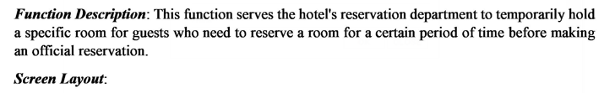
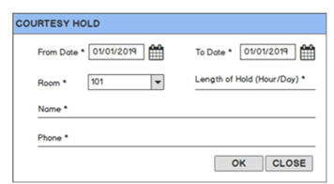
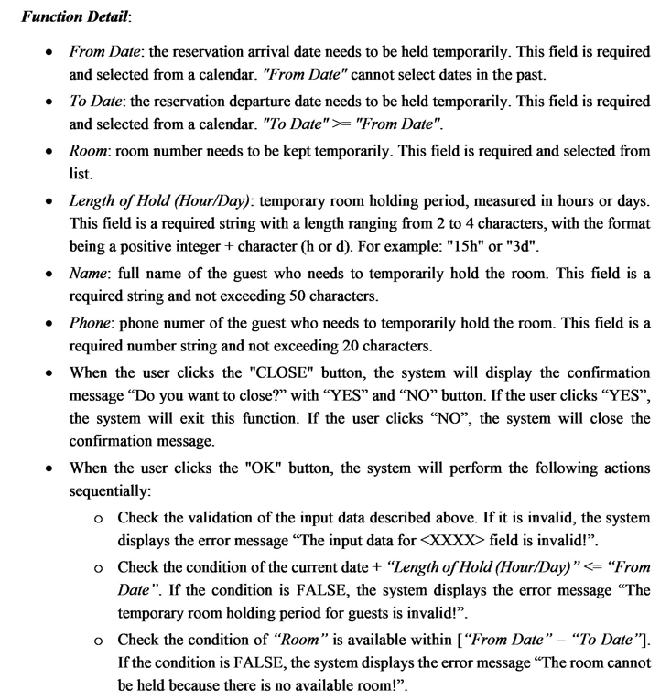
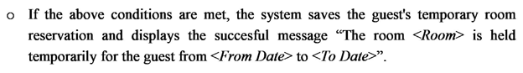
<<Screen Name2>>
[Specification content 1: brief description of the screen/function]
[Specification content 2: the screenshot which is UI layout (Mockup screen) here]
[Specification content 3: descriptions/requirements for the components/fields of the screen here]

2. Non-Functional Requirements

2.1 External Interfaces
[This section provides information to ensure that the system will communicate properly with users and with external hardware or software elements.]

2.2 Quality Attributes
[List all the required system characteristics (quality attributes) specification]

3. Requirement Appendix
[List out other requirements, appendix information etc. in this part]

3.1 Business Rules
[Provide common business rules that you must follow. The information can be provided in the table format as the sample below]

3.2 Common Requirements
[Fill all the common requirements here..]

3.3 Application Messages List

3.4 Other Requirements…

III. Software Design Description
[Provide final software design information follow the template as part II in the Report #4]

1. System Design

1.1 System Architecture
[The content of this section includes the overall diagram which includes the sub-systems, the external systems, and the relationship/connection among them.]

1.2 Package Diagram
[Provide the package diagram for each sub-system. The content of this section includes overall package diagram(s) and the explanation for each package (or namespace)]

2. Database Design
[Provide the files description, database table relationship & table descriptions]

IV. Software Testing Documentation
[Provide final software testing information follow the template as part II in the Report #5]

1. Scope of Testing
[Describe the scopes of the test. Those include the target-of-test’s features, functions, and non-functional requirements that will or will not be tested.
Describe the stages/levels of testing that would be applied to your project - Unit, Integration, or System test. Each includes the in-charge, inputs/time, focuses, acceptance criteria.
List any constraints or assumptions made during the development of this document that may impact the design, development or implementation of testing]

2. Test Strategy
[List out and describe all testing types (you can refer the test types listed below or any other test types to selected the suitable ones for the project; for each selected test types you need to provide the following information: test objective, technique, completion criteria, etc.), test levels that those test types would be performed, & the details of test supporting tools would be used in the project]

2.1 Testing Types
[List out and describe here the testing types which you would apply in your project. You need to mention following information for each type of testing: objective, technique, completion criteria]

2.2 Test Levels
<List out and describe here the testing levels which you would execute in your project. Besides, clearly state the test types which are performed in each test level that you plan for this project>

2.3 Supporting Tools
<List of the test supporting tools which will be employed for this project>

3. Test Cases
[Prepare the details on the test cases following the provided template
- Unit Test Cases: Report5_Unit Test.xls
- Other Test Cases (IT, ST, AT): Report5_Test Report.xls]

4. Test Reports
[Provide the test result, statistics and the relevant test analysis for your testing in the project]

